Module 5:
Creating Python Programs
Jeremy Matthews
Colorado State University Global
CSC500– Principles of Programming
Dr. Douglas Mujeye
Due Date: 03/15/26

Part 1: Rainfall Calculator
Psuedocode
BEGIN Program
DEFINE MONTHS as list of 12 month
// Get valid number of years
REPEAT
PROMPT user for number of years
IF years > 0 THEN
EXIT loop
ELSE
DISPLAY "Please enter a positive number"
END IF
END REPEAT

SET total_rainfall to 0
SET total_months to years * 12

// Collect rainfall data
FOR each year FROM 1 TO num_years
FOR each month FROM 0 TO 11
REPEAT
PROMPT user for rainfall in inches for this year and month
IF rainfall >= 0 THEN
EXIT loop
ELSE
DISPLAY "Rainfall cannot be negative"
END IF
END REPEAT
ADD rainfall to total_rainfall
END FOR
END FOR

// Calculate and display results
SET average_rainfall to total_rainfall / total_months

DISPLAY total number of months
DISPLAY total rainfall (formatted to 2 decimals)
DISPLAY average rainfall per month (formatted to 2 decimals)
END Program
Source Code
MONTHS = [
"January", "February", "March", "April",
"May", "June", "July", "August",
"September", "October", "November", "December"
]

while True:
num_years = int(input("Enter the number of years: "))
if num_years > 0:
break
print("Please enter a positive number of years.")

total_rainfall = 0.0
total_months = num_years * 12

for year in range(1, num_years + 1): # Outer loop: each year
for month in range(12): # Inner loop: each month
while True:
rainfall = float(input(f" Year {year}, {MONTHS[month]} - Enter rainfall (inches): "))
if rainfall >= 0:
break
print(" Rainfall cannot be negative. Try again.")
total_rainfall += rainfall

average_rainfall = total_rainfall / total_months

print("\n--- Rainfall Summary ---")
print(f"Number of months : {total_months}")
print(f"Total rainfall : {total_rainfall:.2f} inches")
print(f"Average per month : {average_rainfall:.2f} inches")

Screenshots
Application Executing Program
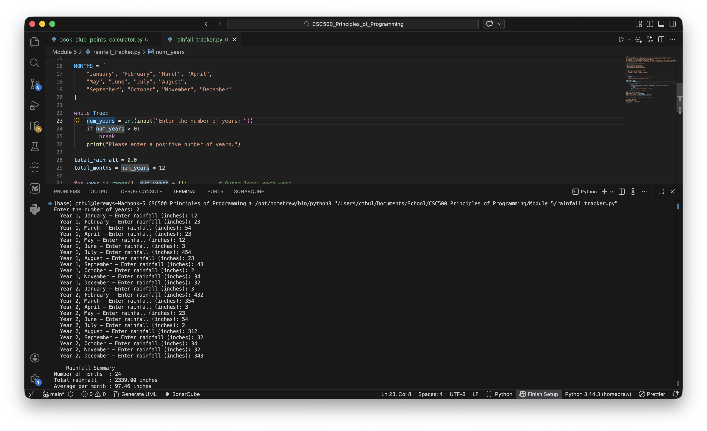
Results
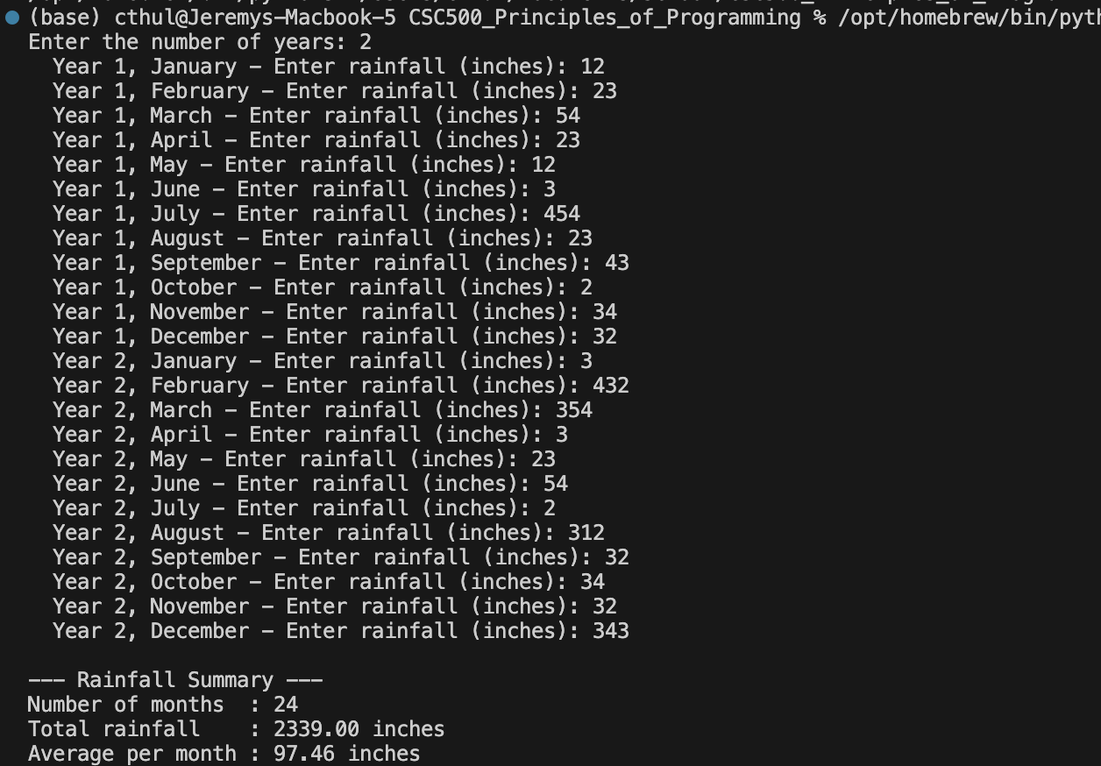
Part 2: Book Club Points Calculator
Pseudocode
BEGIN Program
PROMPT user "Enter the number of books purchased this month"
READ books

IF books is not a valid non-negative integer THEN
DISPLAY "Please enter a valid non-negative whole number."
ELSE
CONVERT books to integer

IF books >= 8 THEN
SET points = 60
ELSE IF books >= 6 THEN
SET points = 30
ELSE IF books >= 4 THEN
SET points = 15
ELSE IF books >= 2 THEN
SET points = 5
ELSE
SET points = 0
END IF

DISPLAY "Books purchased:", books
DISPLAY "Points awarded:", points
END IF
END Program
Source Code
books = input("Enter the number of books purchased this month: ")

# Validate input is a non-negative integer
if not books.isdigit():
print("Please enter a valid non-negative whole number.")
else:
books = int(books)

if books >= 8:
points = 60
elif books >= 6:
points = 30
elif books >= 4:
points = 15
elif books >= 2:
points = 5
else:
points = 0

print(f"\nBooks purchased : {books}")
print(f"Points awarded : {points}")
Screenshots
Application Executing Program
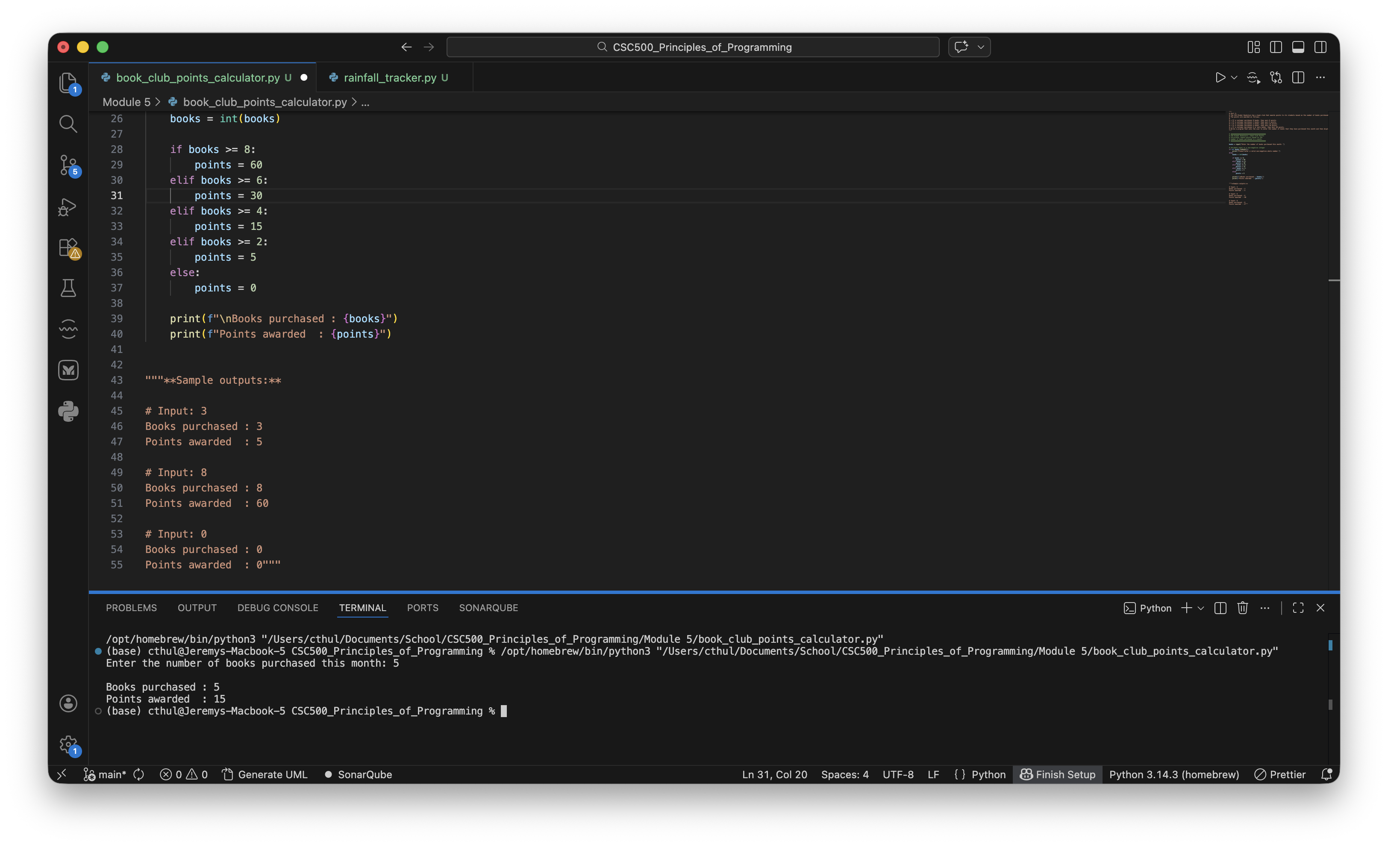
Results
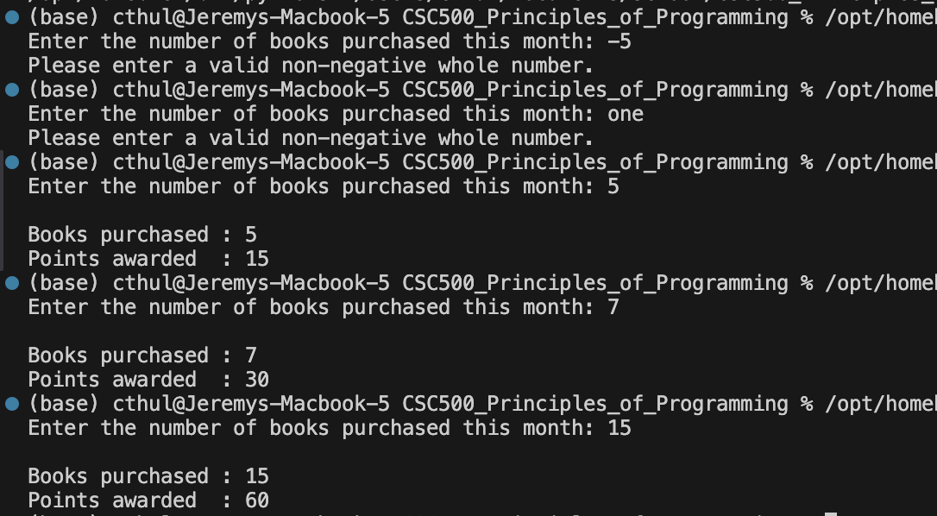
Github Repository
https://github.com/m9dful1/CSC500_Principles_of_Programming/tree/main/Module%205

